You Have Data Rights:

The law says that you own the information that organisations hold about you. This might be your name, age, address and other personal information. It covers information held on computers and on paper.

When Swan Advocacy helps you, we need information like your name, age, address and phone number. We might need information about your care plan, your history and any difficulties you might be having. We promise to look after your data but your data also belongs to you and you have some important rights:

The right to be informed
You have the right to be told about the
information we need to hold, why we need it and how long we will keep it for.

The right of access
You have the right to see the information we keep about you.

The right to correction (rectification)
If the information we hold about you is not right, you can ask us to correct it. We have to reply to you within a month.

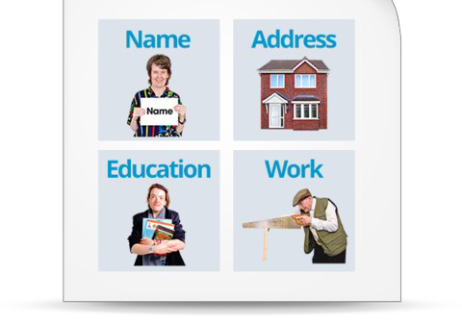
The right to be forgotten
X
You can ask us to delete all the information we hold about you. There are some reasons why this may not be possible for all your data, but we will tell you that. We have to reply within one month.

The right to object
You can object to your information being used for anything that isn’t about your Advocacy.

You can find more information on the ICO website: www.ico.org.uk or you can contact Swan Advocacy on 03333447928 or GDPR@swan.advocacy.org.uk

