Volunteer Application
Confidential
The information provided in this application form will be used for the purposes of recruitment and selection and stored in accordance with the Data Protection Act 2018. Please see the end of the application form for more information about how we use your data.
If you have any difficulties completing this application form, please do not hesitate to contact us on 03333 447928 or email volunteer@swanadvocacy.org.uk
Personal Details
Title:
First Name: | Last Name:
Address:
Postcode:
Telephone Number: | Telephone Mobile:
Email Address:
Are you a Driver  This helps us to work out the areas you could cover as a volunteer. It is not required for all roles. | Yes ☐ No ☐
Are there any restrictions on you taking up a voluntary role in the UK? | Yes ☐ No ☐
If yes, please specify:
Are you doing any other voluntary work now, or have you done so recently? | Yes ☐ No ☐
If yes, please give details:

Have you been a client of SWAN? |  | Yes ☐ No ☐
More about you and what you could bring to our volunteer roles
Where did you hear about voluntary opportunities with SWAN?
What do you hope to gain from volunteering with SWAN?
Do you have any personal, professional, or voluntary experience of advocacy or working with vulnerable individuals and who have care and support needs, can you give us some details about this?
If you don’t yet, can you tell us what other personal or professional skills or experience you have that you feel you could bring to the role of a SWAN Volunteer?
How much time can you commit to your volunteering role? (Days/hours per week, this is a rough guide and can be discussed and changed later)
What SWAN will need from you
If you are seeking to volunteer in a particular service you may need to travel across a wide area, expenses for this will be reimbursed. Could you tell us how far you would be willing to travel?
Training is provided and all volunteers will receive an induction into their role. You will be required to attend all mandatory training when required. Induction and training may be delivered remotely or in person at your nearest office. The Induction is up to 3 hours and training equates to roughly 1 hour per month. Are you willing to commit to this? Yes ☐ No☐
SWAN provides all staff and volunteers with regular supervision every 6-8 weeks. Are you willing to attend supervision when necessary and requested? Yes ☐ No☐
Which roles are of interest to you volunteering with us?
Please visit https://swanadvocacy.org.uk/volunteer for a full description of all the roles.
Please email volunteer@swanadvocacy.org.uk or call 07928525693 if you wish to discuss any of these roles first.
Please tick all that apply. Role available in
Not sure yet | ☐
Volunteer Relevant Persons Representative | ☐ Bristol, Isle of Wight, Somerset & South Glos
Volunteer Community Advocate | ☐ Somerset & South Glos
Volunteer Carers Community Champion | ☐ Dorset
Volunteer Victim Advocate | ☐ Avon & Somerset Counties
Volunteer Advocacy Coach | ☐ All areas of delivery
Volunteer Community Champion | ☐ All areas of delivery

You are welcome to submit any additional information in support of your application, but it must be accompanied by this completed and signed application form.

DBS Clearance
We welcome applications from anyone who would like to volunteer with us, but if you wish to undertake a volunteer role, we will require you to complete a Disclosure and Barring Service Check which will disclose any criminal offences.
Please answer the following:

Do you have any unspent conditional cautions or convictions under the Rehabilitation of Offenders Act 1974? | Yes ☐ No ☐
Do you have any adult cautions (simple or conditional) or spent convictions that are not protected as defined by the Rehabilitation of Offenders Act 1974 (Exceptions) Order 1975 (Amendment) (England and Wales) Order 2020? | Yes ☐ No ☐
The amendments to the Rehabilitation of Offenders Act 1974 (Exceptions) Order 1975 (2013 and2020) provides that when applying for certain jobs and activities, certain convictions and cautions are considered ‘protected’. This means that they do not need to be disclosed to employers, and if they are disclosed, employers cannot take them into account.
Guidance about whether a conviction or caution should be disclosed can be found on the Ministry of Justice website.
Please note that ticking yes to any of the above will not mean that you cannot volunteer with us, but we will carry out a risk assessment based around the role for which you are applying.

If yes, please specify:
Do you consent to an appropriate level DBS Check? | Yes ☐ No ☐

Equality Monitoring Survey: We would like to know a little bit more about those who would like to volunteer with us, but we understand that not everyone is comfortable sharing this information. If you would be happy to share some more information, then please could you complete the anonymous Volunteer Equality Monitoring Survey available here https://forms.office.com/r/MGVp8KNiuS
If you require a physical copy of this form please contact volunteer@swanadvocacy.org.uk

References

We have a duty to ensure as far as possible that the interests of our clients are protected. For that reason, please provide names and addresses of two responsible persons who would be willing to provide references. One reference should relate to your present or most recent employment or voluntary agency you may have worked or volunteered for.

The other should know you personally but should not be a friend or a member of your family. If you are unsure whom to give as a referee, please discuss this with the Volunteer Manager.

Reference 1
Name
Relationship
Address
Occupation
Tel No
Email

Reference 2
Name
Relationship
Address
Occupation
Tel No
Email
I confirm that to the best of my knowledge the information given on this form is true and correct.
Signature: …………………………………………. Date: …../…../……
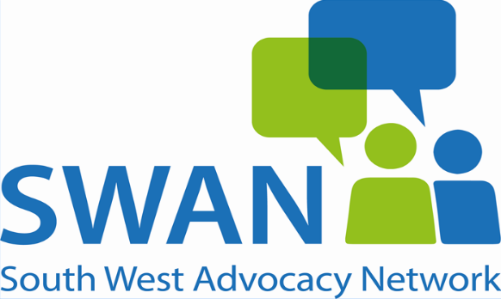 | Please return your completed application by post or email to:  Volunteer Manager  SWAN  Hi Point  Thomas Street  Taunton  TA2 6HB  Email: volunteer@swanadvocacy.org.uk
How we use your data
As noted above we will use the information supplied in this application form for the purposes of recruitment and volunteering with SWAN. You have a right request to view Personal Data we hold about you. By completing this application form you consent to us storing this information for the purposes of you volunteering with us. After making an application SWAN will store your details for 6 months.
If you wish to discuss how your data is used before submitting this form, you can phone us on 03333 447928 or you can email: GDPR@SWANadvocacy.org.uk or read our full Privacy Notice on our website: www.SWANadvocacy.org.uk

