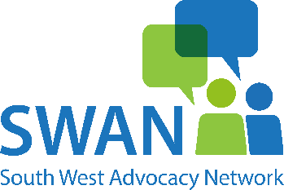
Spot Purchase Agreement

Please note: We will not allocate to an advocate until this agreement is returned to us fully completed with a valid Purchase Order Number*.
If not returned within 2 weeks of referral date, then the case will be closed, and a new referral will be required.
By completing and signing this form you agree to purchase Advocacy support as detailed on this form at a cost of £46 per hour. This charge includes administration, visit time and travel time plus any other actions required by the advocate. Travelling expenses are not charged separately.
If an estimate of time has been given by SWAN, this is not final, and the final amount invoiced could change.

Client Name:
Local Authority Client ID:
*Purchase Order No.
Type of Advocacy Required: | ☐ | Care Act
Type of Advocacy Required: | ☐ | Paid Representative
Type of Advocacy Required: | ☐ | Rule 1.2
Type of Advocacy Required: | ☐ | Litigation Friend
Type of Advocacy Required: | ☐ | CHC
County where Advocacy will be carried out:
Contact name and title of Responsible Authority:
Referring Team:
Invoice Name and Address:
Email Address to Send Invoices:
Period covered by Purchase Order:
Any specific requirements:
e.g. frequency of reports, time restrictions, type of meeting etc.
Signature on behalf of commissioning body or person:
Date:

